Computing Essential Knowledge and skills Autumn KS1 2022-2023
N.C Objectives: Key Stage 1 | Essential 1 | Essential 2 | Essential 3
Recognise common uses of information technology beyond school. (Digital Literacy)  Use technology purposefully to create, organise, store, manipulate and retrieve digital content. (IT) | Knowledge  Understand what is meant by technology and can identify a variety of examples both in and out of school.  Make a distinction between objects that use modern technology and those that do not e.g. a microwave vs. a chair. | Knowledge  Make links between technology they see around them, coding and multimedia work they do in school.  Apply their learning of effective searching beyond the classroom. They can share this knowledge, e.g. 2Publish example template. | Knowledge  Apply their learning of effective searching beyond the classroom.  Effectively retrieve relevant, purposeful digital content using a search engine.
 | Skills  Save and retrieve work. (using Purple Mash)  Purple mash unit 1.9 Tech outside school. | Skills  Retrieve relevant, purposeful digital content using a search engine.  Purple mash unit 2.5 – Effective searching. | Skills  Apply their knowledge of various technology and programmes to purposefully to create, organise, store, manipulate and retrieve digital data  Purple mash unit 2.8 – Presenting ideas.
 | Target Tracker objectives: 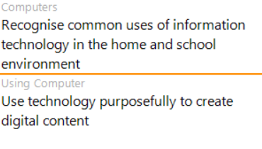 | Target Tracker objectives:  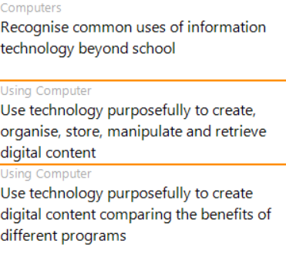

23Computing Essential Knowledge and skills Autumn LKS2 2022-2023
N.C Objectives: Key Stage 2 | Essential 1 | Essential 2 | Essential 3
Understand computer networks, including the internet; how they can provide multiple services, such as the World Wide Web, and the opportunities they offer for communication and collaboration.  (Computer Science)  Use search technologies effectively, appreciate how results are selected and ranked, and be discerning in evaluating digital content. (IT)  Use technology safely, respectfully and responsibly (Digital Literacy) | Knowledge  Recognise input and output devices and understand computer networks and the internet.  Use simple search technologies and recognise acceptable and unacceptable behaviour. | Knowledge  Understand what servers are and how they provide a service.  Understand the function, features and layout of a search engine.  Understand the online safety implications associated with the ways the internet can be used to provide different methods of communication. | Knowledge  Recognise the main component parts of hardware which allow computers to join and form a network.
 | Skills  Carry out simple searches to retrieve digital content. Understand that to do this, they are connecting to the internet and using a search engine such as Purple Mash search or internet-wide search engines.  https://www.barefootcomputing.org/resources/selecting-search-activity  https://teachcomputing.org/curriculum/key-stage-2/computing-systems-and-networks-connecting-computers/lesson-1-how-does-a-digital-device-work  Purple mash unit 3.5 – 2Email. | Skills  Check selected webpages for credibility and information at a basic level.  Purple mash unit 4.7 – Effective Searching . | Skills  Purple mash unit 4.8– Hardware investigators.
 | Target Tracker objectives: 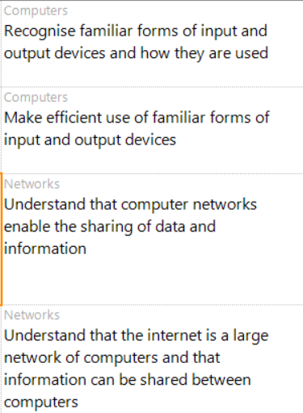 | Target Tracker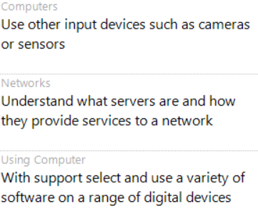
Computing Essential Knowledge and skills Autumn UKS2 2022-2023
N.C Objectives: Key Stage 2 | Essential 1 | Essential 2 | Essential 3
Understand computer networks, including the internet; how they can provide multiple services, such as the World Wide Web, and the opportunities they offer for communication and collaboration.  (Computer Science)  Use search technologies effectively, appreciate how results are selected and ranked, and be discerning in evaluating digital content. (IT)  Use technology safely, respectfully and responsibly (Digital Literacy) | Knowledge  Search with greater complexity for digital content when using a search engine. Explain in some detail how credible a webpage is and the information it contains.  Understand the value of computer networks but are also aware of the main dangers. Recognise what personal information is and can explain how this can be kept safe. | Knowledge  Understand and explain in some depth the difference between the internet and the World Wide Web.  Know what a WAN and LAN are and can describe how they access the internet in school. | Knowledge  Compare a range of digital content sources and are able to rate them in terms of content quality and accuracy.
 | Skills  Use filters in search technology effectively and appreciate how results are selected and ranked.  Select the most appropriate form of online communications contingent on audience and digital content, e.g. 2Blog,  https://www.barefootcomputing.org/resources/ranking-search-activity  Purple mash unit 5.5 2Blog. | Skills  Apply filters when searching for digital content. Explain in detail how credible a webpage is and the information it contains.  Use online communications effectively.  Purple mash unit 6.6 Networks | Skills  Use critical thinking skills in everyday use of online communication.  Purple mash unit 6.4 Blogging
 | Target Tracker objectives:  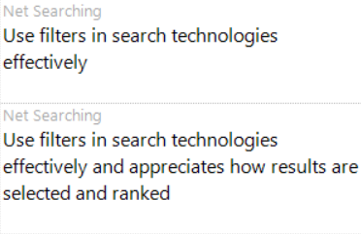 | Target Tracker  