Art and Design Curriculum – Cycle A
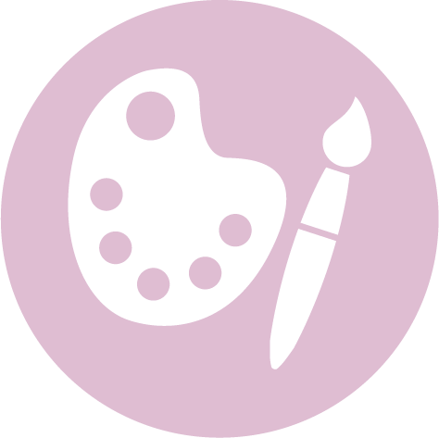

Upper Key Stage 2 – Year 5 & 6
- to create sketch books to record their observations and use them to review and revisit ideas
- to improve their mastery of art and design techniques, including drawing, painting and sculpture with a range of materials [for example, pencil, charcoal, paint, clay]
- about great artists, architects and designers in history.

Autumn | Spring | Summer
Unit Title:Drawing and Colour – Graffiti Art |  | Unit Title: Printing – Pop Art
Artist:Corey Barksdale 1972 –  Movement: Post Modernism  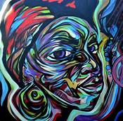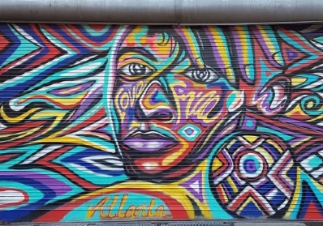  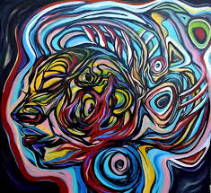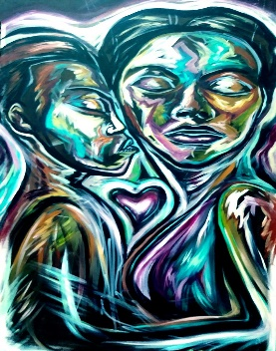  https://www.bbc.co.uk/teach/abstract-art-timeline-colour-and-shape/zmhy6v4  https://www.coreybarksdale.com/about.html  https://www.youtube.com/watch?v=Y_9L97MJ1-c&list=PLi4I83Z4sTcAHusSOC46w_YkALKQRpCva&index=2  https://www.youtube.com/watch?v=cqY0vfhT72U |  | Artist:Andy Warhol 1928 –1987  Movement:Post Modernism  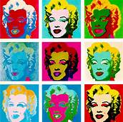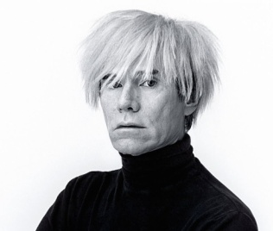  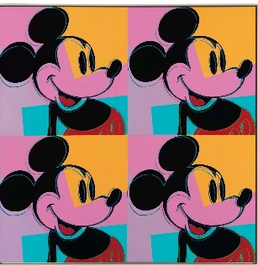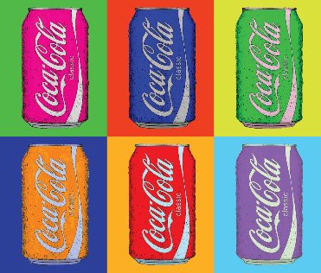  https://www.tate.org.uk/kids/explore/who-is/who-andy-warhol  https://www.bbc.co.uk/teach/class-clips-video/art-and-design-ks2-andy-warhols-marilyn-diptych/z42r2sg  https://youtu.be/DhEyoDCTSDQ  https://www.bbc.co.uk/teach/class-clips-video/art-and-design-printmaking-different-materials/zhytscw
Prior Knowledge:  - Use a sketchbook for recording observations, for experimenting with techniques or planning out ideas. (3)  - Experiment with different materials to create a range of effects and use these techniques in the completed piece of work. (3)  - Explain what he/she likes or dislikes about their work. (3)  - Know about some of the great artists, architects and designers in history and describe their work. (3)  - Understand and identify key aspects such as complementary colours, colour as tone, warm and cold colours. (3)  - Use a sketchbook for collecting ideas and developing a plan for a  completed piece of artwork. (4)  - Use taught technical skills to adapt and improve his/her work. (4)  - Articulate how he/she might improve their work using technical terms and reasons as a matter of routine. (4)  - Describe some of the key ideas, techniques and working practices of artists, architects and designers who he/she has studied. (4)  - Create different effects by using a variety of tools and techniques such asbleeds, washes, scratches and splashes. (4)  - Experiment with creating mood, feeling, movement and areas of interest by selecting appropriate materials and learnt techniques. (4)  Prior Vocabulary:  Mood, feeling, movement  Complementary colours, tone, warm and cold colours  Artists, designers, architects  Primary, secondary colours |  | Prior Knowledge:  - Use a sketchbook for recording observations, for experimenting withtechniques or planning out ideas. (3)  - Experiment with different materials to create a range of effects and usethese techniques in the completed piece of work. (3)  - Explain what he/she likes or dislikes about their work. (3)  - Know about some of the great artists, architects and designers in historyand describe their work. (3)  - Use a sketchbook for collecting ideas and developing a plan for a  completed piece of artwork. (4)  - Use taught technical skills to adapt and improve his/her work. (4)  - Articulate how he/she might improve their work using technical terms andreasons as a matter of routine. (4)  - Describe some of the key ideas, techniques and working practices of artists,architects and designers who he/she has studied. (4)  - Understand and identify key aspects such as complementary colours, colouras tone, warm and cold colours. (3)  - Create printing blocks using relief or impressed techniques. (3)  - Draws familiar objects with correct proportions. (4)  - Use a variety of techniques e.g. marbling, silkscreen and cold water paste. (4)  - Print on fabrics using tie-dyes or batik. (4)  Prior Vocabulary:  Print, printing  Artists, designers, architects  Primary, secondary colours
Skills:  - Mix colours to express mood ordemonstrate tones. (5)  - Return to work over longer periods of time and use a wider range ofmaterials. (5)  - Use different techniques, colours and textures when designing and making pieces of work and explain his/her choices. (6) |  | Skills:  - Return to work over longer periods of time and use a wider range ofmaterials. (5)  - Mix colours to express mood (Y5)  - Use different techniques, colours and textures when designing and makingpieces of work and explain his/her choices. (6)  - Create intricate printing patterns by simplifying and modifying sketchbookdesigns. (6)
Knowledge:  - Develop different ideas which can be used and explain his/her choices for the materials and techniques used. (5)  - Confidently and systematically investigate the potential of new and unfamiliar materials and use these learnt techniques within his/her work. (5)  - Evaluate his/her work against their intended outcome. (5)  - Research and discuss various artists, architects and designers and discuss their processes and explain how these were used in the finished product. (5)  - Select ideas based on first hand observations, experience or imagination and develop these through open ended research. (6)  - Refine his/her use of learnt techniques. (6)  - Adapt his/her own final work following feedback or discussion based on their preparatory ideas. (6)  - Describe the work and ideas of various artists, architects and designers, using appropriate vocabulary and referring to historical and cultural contexts. (6)  - Explain and justify preferences towards different styles and artists. (6) |  | Knowledge:  - Develop different ideas which can be used and explain his/her choices forthe materials and techniques used. (5)  - Confidently and systematically investigate the potential of new and  unfamiliar materials and use these learnt techniques within his/her work.(5)  - Evaluate his/her work against their intended outcome. (5)  - Research and discuss various artists, architects and designers and discusstheir processes and explain how these were used in the finished product. (5)  - Select ideas based on first hand observations, experience or imaginationand develop these through open ended research. (6)  - Refine his/her use of learnt techniques. (6)  - Adapt his/her own final work following feedback or discussion based ontheir preparatory ideas. (6)  - Describe the work and ideas of various artists, architects and designers,using appropriate vocabulary and referring to historical and cultural contexts. (6)  - Explain and justify preferences towards different styles and artists.  (6)
Key moments in sketchbook:  - Artist research (Barksdale)  - Experiment with different techniques, colours and textures to express mood or demonstrate tones.  - Annotations to show reflections on their work and that of others. |  | Key moments in sketchbook:  - Artist research (Warhol)  - Experiment with different techniques, colours and textures to express mood.  - Annotations to show reflections on their work and that of others.
Final artwork:  Barksdale inspired abstract portrait |  | Final artwork:  Warhol inspired pop art print
Key Vocabulary:  Elements of art – colour, line, shape, texture, value, tone  Abstract  Graffiti art  Mural/muralist  Mood/feeling  Back to back  Hip-hop  Writer |  | Key Vocabulary:  Elements of art – colour, line, shape, space, texture, value  Pop art  Contemporary  Abstract art  Screen printing  Repeated images  Graphic design  Computer aided design (CAD)
Curriculum links:  History, Music |  | Curriculum links:  History
Jobs in Art & Design:  Fashion, textile designers  Architect  Interior designer  Animator  Illustrator  Web designer  Graphic designer  Photographer  Computer aided designer |  | Jobs in Art & Design:  Fashion, textile designers  Architect  Interior designer  Animator  Illustrator  Web designer  Graphic designer  Photographer  Computer aided designer

