Art and Design Curriculum – Cycle B
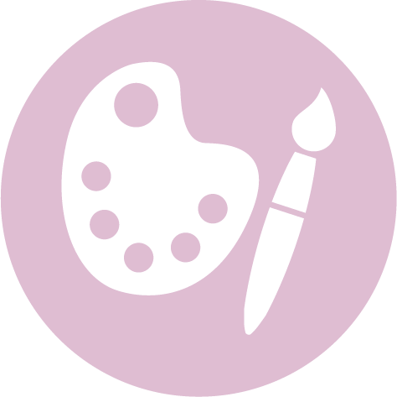

Lower Key Stage 2 – Year 3 & 4
- to create sketch books to record their observations and use them to review and revisit ideas
- to improve their mastery of art and design techniques, including drawing, painting and sculpture with a range of materials [for example, pencil, charcoal, paint, clay]
- about great artists, architects and designers in history.

Autumn | Spring | Summer
Unit Title: Drawing and Colour - watercolour |  | Unit Title: Collage – visual art
Artist: Georgia O’Keefe 1887 – 1986  Movement: American Modernism, Precisionism  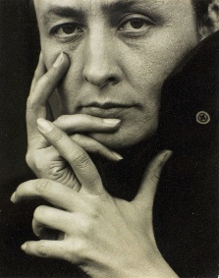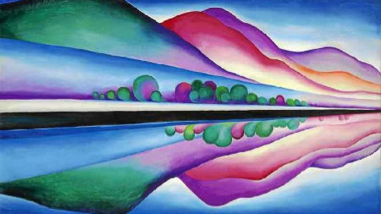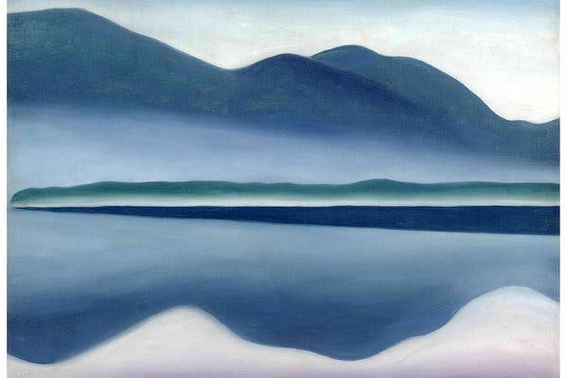  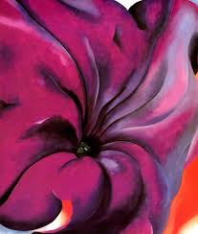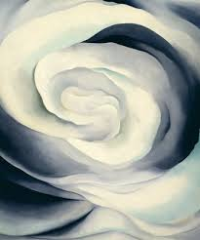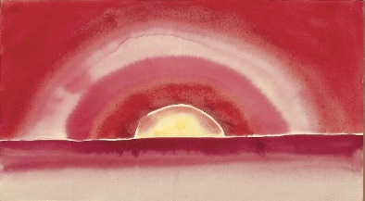  https://www.tate.org.uk/kids/explore/who-is/who-georgia-okeeffe  https://www.pinterest.co.uk/patty_palmer2/georgia-okeeffe-art-project-for-kids/  Compare with the work of:  Artist: Emma Larrson  Movement: Contemporary  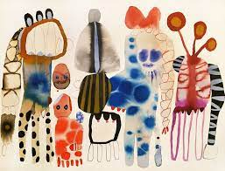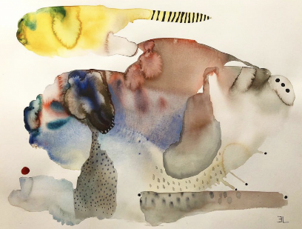  https://www.hugoandmarie.com/artists/emma-larsson/ |  | Artist: Andy Goldsworthy  Movement: Contemporary  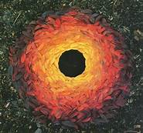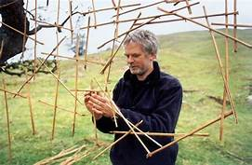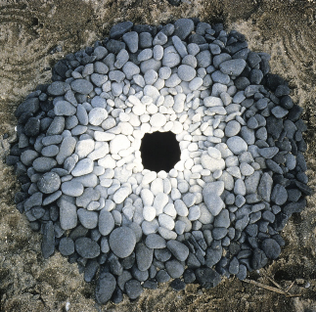  https://www.bbc.co.uk/bitesize/clips/zh4wmp3  https://www.slideshare.net/nivaca2/andy-goldsworthy-for-kids  Compare with the work of:  Artist: Jaume Plensa 1955 -  Movement: Contemporary  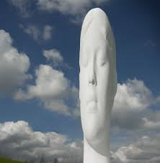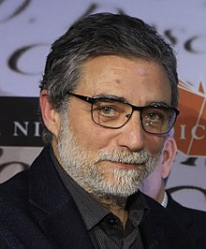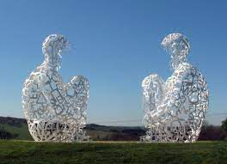  https://jaumeplensa.com/  https://en.wikipedia.org/wiki/Jaume_Plensa
Prior Knowledge: KS1  Pupils should be taught:  - to use a range of materials creatively to design and make products  - to use drawing, painting and sculpture to develop and share their ideas, experiences and imagination  - to develop a wide range of art and design techniques in using colour, pattern, texture, line, shape, form and space  - about the work of a range of artists, craft makers and designers, describing the differences and similarities between different practices and disciplines, and making links to their own work  Prior Vocabulary:  Materials  Drawing, painting  Colour, pattern, texture, line, shape, form space  Artists, craft makers, designers  Similar, different |  | Prior Knowledge: KS1  Pupils should be taught:  - to use a range of materials creatively to design and make products  - to use drawing, painting and sculpture to develop and share their ideas, experiences and imagination  - to develop a wide range of art and design techniques in using colour, pattern, texture, line, shape, form and space  - about the work of a range of artists, craft makers and designers, describing the differences and similarities between different practices and disciplines, and making links to their own work  Prior Vocabulary:  Materials  Drawing, painting  Colour, pattern, texture, line, shape, form space  Artists, craft makers, designers  Similar, different
Skills:  - Explore shading, using different media. (3)  - Understand and identify key aspects such as complementary colours, colour as tone, warm and cold colours. (3)  - Compare and recreate form of natural and manmade objects. (3)  - Create different effects by using a variety of tools and techniques such as bleeds, washes, scratches and splashes. (4)  - Experiment with creating mood, feeling, movement and areas of interest by selecting appropriate materials and learnt techniques. (4) |  | Skills:  - Explore shading, using different media. (3)  - Understand and identify key aspects such as complementary colours, colour as tone, warm and cold colours. (3)  - Compare and recreate form of natural and manmade objects. (3)  - Create a collage using overlapping and layering. (3)  - Experiment with creating mood, feeling, movement and areas of interest by selecting appropriate materials and learnt techniques. (4)
Knowledge:  - Use a sketchbook for recording observations, for experimenting with techniques or planning out ideas. (3)  - Experiment with different materials to create a range of effects and use these techniques in the completed piece of work. (3)  - Explain what he/she likes or dislikes about their work. (3)  - Know about some of the great artists, architects and designers in history and describe their work. (3)  - Use a sketchbook for collecting ideas and developing a plan for a  completed piece of artwork. (4)  - Use taught technical skills to adapt and improve his/her work. (4)  - Articulate how he/she might improve their work using technical terms and reasons as a matter of routine. (4)  - Describe some of the key ideas, techniques and working practices of artists, architects and designers who he/she has studied. (4) |  | Knowledge:  - Use a sketchbook for recording observations, for experimenting with techniques or planning out ideas. (3)  - Experiment with different materials to create a range of effects and use these techniques in the completed piece of work. (3)  - Explain what he/she likes or dislikes about their work. (3)  - Know about some of the great artists, architects and designers in history and describe their work. (3)  - Use a sketchbook for collecting ideas and developing a plan for a  completed piece of artwork. (4)  - Use taught technical skills to adapt and improve his/her work. (4)  - Articulate how he/she might improve their work using technical terms and reasons as a matter of routine. (4)  - Describe some of the key ideas, techniques and working practices of artists, architects and designers who he/she has studied. (4)
Key moments in sketchbook:  - Artist research (O’Keeffe)  - Experiment with shading, using different media.  - Experiment with different techniques to show complementary colours, colour as tone, warm and cold colours.  - Experiment with different effects, tools and techniques such as bleeds, washes, scratches and splashes.  - Experiment with different techniques to create mood, feeling, movement and areas of interest.  - Annotations to show reflections on their work and that of others. |  | Key moments in sketchbook:  - Artist research (Deborah Shapiro)  - Experiment with shading, using different media.  - Experiment with different techniques to show complementary colours, colour as tone, warm and cold colours.  - Experiment with different techniques to create mood, feeling, movement and areas of interest.  - Annotations to show reflections on their work and that of others.
Final artwork:  O’Keeffe inspired art work |  | Final artwork:  Shapiro inspired collage
Key Vocabulary:  Vibrant, bold  Complementary colours  Colour, form, line, shape, space, texture, value, pattern, tone  Warm/cold colours  Abstract/abstraction  Legacy  Modernism |  | Key Vocabulary:  Collage  Complementary colours  Colour, form, line, shape, space, texture, value, pattern, tone  Warm/cold colours  Abstract/abstraction
Curriculum links:  Geography |  | Curriculum links:

