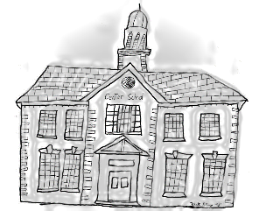
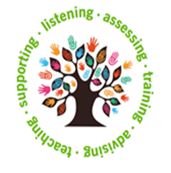
ST Helens

Local Autism and Social Communication Service

Year 6 TRANSITION Online Parent Sessions

If your child is due to transition to High School in September 2023, we would love you to join us on our online sessions to share tips and advice.

At this time of year you will have completed applications to name your 3 preferred high school places, in light of this we felt it was important to offer you support to be able to effectively plan the next steps of your journey.

LASCS focus is towards children with Social Communication differences or those who have a diagnosis of Autism, but we recognise that many of the strategies discussed work for most children who require that little bit of additional support.

Note that the sessions are directed to parents/carers and not to the young people; if you can attend all four it would be more beneficial.

Session One – The Year Ahead
Friday 25th November 2022 – 12:30 – 13:30
Session Two – Building Blocks
Friday 3rd February 2023 - 12:30 – 13:30
Session Three – A Helping Hand
Friday 24th March 2023 - 12:30 – 13:30
Session Four – The Finish Line is in Sight!
Friday 12th May 2023 - 12:30 – 13:30

For further information or to register an interest, please email us LASCStransitions@sthelens.gov.uk
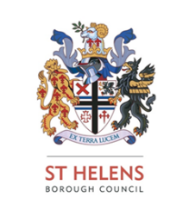
Together, we can make a difference! We look forward to meeting you.

