Art and Design Curriculum – Cycle A
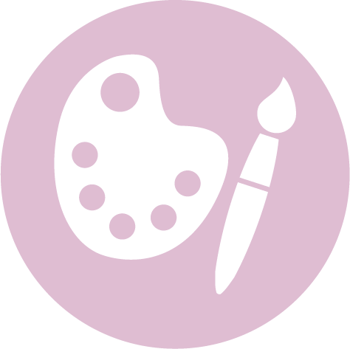
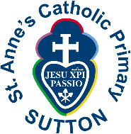

Key Stage 1 – Year 1 & 2
- to use a range of materials creatively to design and make products
- to use drawing, painting and sculpture to develop and share their ideas, experiences and imagination
- to develop a wide range of art and design techniques in using colour, pattern, texture, line, shape, form and space
- about the work of a range of artists, craft makers and designers, describing the differences and similarities between different practices and disciplines, and making links to their own work.

Autumn | Spring | Summer
Unit Title:Drawing and Colour |  | Unit Title: Printing
Artist:Joan Miro 1893-1983  Movement: Surrealism, Modernism, Dada  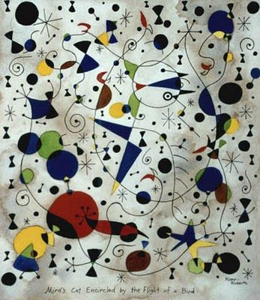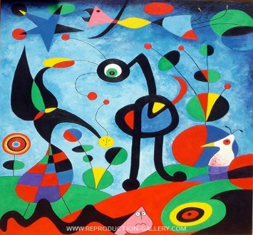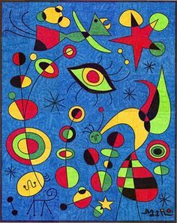  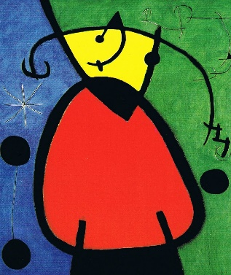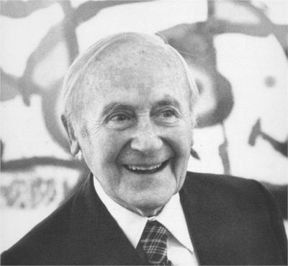  https://www.youtube.com/watch?v=UYLZQFOD1BE  https://www.youtube.com/watch?v=O9rAdb_ULp0  https://www.twinkl.co.uk/blog/abstract-art-for-kids |  | Artist:Piet Mondrian 1872 – 1944  Movement:De Stijl, Modernism, Cubism  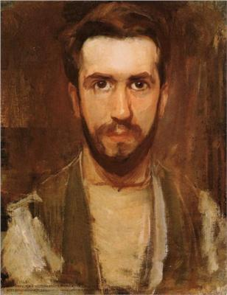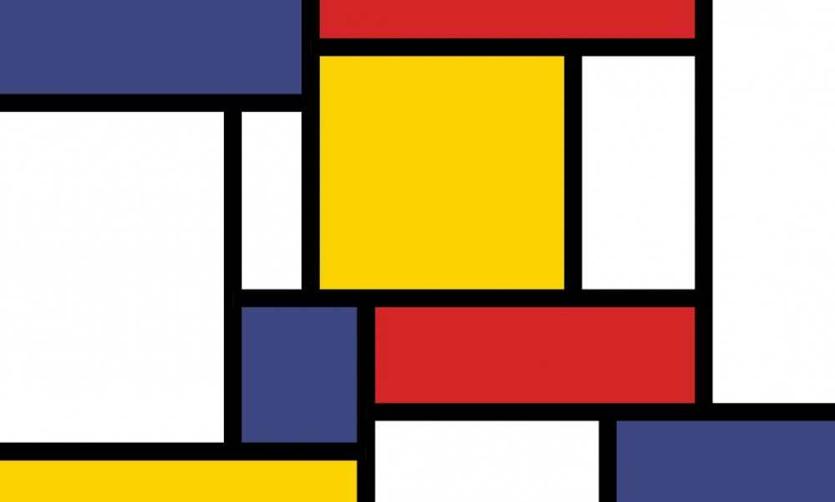  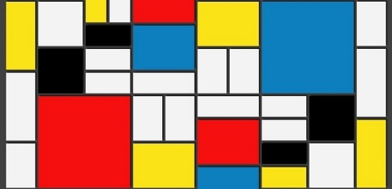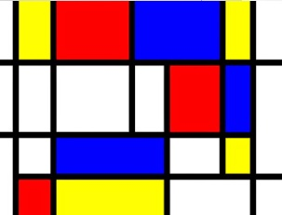  https://www.bbc.co.uk/teach/class-clips-video/art-and-design-printmaking-different-materials/zhytscw  https://www.tate.org.uk/kids/explore/who-is/who-piet-mondrian
Prior Knowledge: EYFS  - Safely use and explore a variety of materials, tools and techniques, experimenting with colour, design, texture, form and function.  - Use what they have learnt about media and materials in original ways, thinking about uses and purposes.  - Represent their own ideas, thoughts and feelings through art.  Prior Vocabulary:  Shapes  Paint, draw, colour  Colours  Pencil, crayon, paint, chalk |  | Prior Knowledge: EYFS  - Safely use and explore a variety of materials, tools and techniques, experimenting with colour, design, texture, form and function.  - Use what they have learnt about media and materials in original ways, thinking about uses and purposes.  - Represent ideas, thoughts and feelings through art.  Prior Vocabulary:  Shapes  Paint, draw, colour  Colours
Skills  - Use a variety of tools including pencils, rubbers, crayons, pastels, felt tips, charcoal, ballpoints, chalk and other dry media to represent objects in lines. (1)  - Explore mark-making using a variety of tools. (1)  - Experiment with tones using pencils, chalk or charcoal. (2)  - Represent things observed, remembered or imagined using colour/tools in two and three dimensions. (2) |  | Skills:  - Explore mark-making using a variety of tools. (1)  - Make marks in print using found objects and basic tools and use these tocreate repeating patterns. (1)  - Use a variety of techniques including carbon printing, relief, press and fabricprinting and rubbings. (2)
Knowledge:  - Use artwork to record ideas, observations and experiences. (1)  - Explain what he/she likes about the work of others. (1)  - Know the names of tools, techniques and elements that he/she uses. (1)  - Try out different activities and make sensible choices about what to do next. (2)  - Select particular techniques to create a chosen product and develop some care and control over materials and their use. (2)  - Give reasons for his/her preferences when looking at art/craft or design work. (2)  - Know that different artistic works are made by craftspeople from different cultures and times. (2) |  | Knowledge:  - Use artwork to record ideas, observations and experiences. (1)  - Experiment with different materials to design and make products in two andthree dimensions. (1)  - Explain what he/she likes about the work of others. (1)  - Know the names of tools, techniques and elements that he/she uses.(1)  - Try out different activities and make sensible choices about what to do next. (2)  - Select particular techniques to create a chosen product and develop somecare and control over materials and their use. (2)  - Give reasons for his/her preferences when looking at art/craft or design  work. (2)  - Know that different artistic works are made by craftspeople from differentcultures and times. (2)
Key moments in sketchbook:  - Artist research (Joan Miro)  - Experiment with a range of materials.  - Experiment withcolour, line, shape, space.  - Annotations to show reflections on their work and that of others. |  | Key moments in sketchbook:  - Artist research (Piet Mondrian)  - Experiment with a range of natural materials.  - Experiment with colour, form, texture  - Annotations to show reflections on their work and that of others.
Final artwork:  A Miro inspired piece of art work |  | Final artwork:  A print design in the style of Mondrian
Key Vocabulary:  Elements of art – colour, line, shape, space  Artist, designer, design  Media, materials  Warm/cool colours  Primary/secondary colours |  | Key Vocabulary:  Elements of art – colour, line, shape, space  Artist, designer, design  Media, materials  Warm/cool colours  Primary/secondary colours  Printing
Curriculum links:  History - artist |  | Curriculum links:  Maths – shape & space
Jobs in Art & Design:  Fashion, textile designers  Architect  Interior designer  Animator  Illustrator  Web designer  Graphic designer  Photographer  Computer aided designer |  | Jobs in Art & Design:  Fashion, textile designers  Architect  Interior designer  Animator  Illustrator  Web designer  Graphic designer  Photographer  Computer aided designer

