Year: | 4 | Aim | To make links and connections to show that we are all different. To celebrate these differences as we appreciate that God’s love accepts us as we are now and as we change.
Strand | Physical | Learning intention | To describe how we should treat others making links with the diverse modern society we live in.

What should I already know? | What will I learn?
How we should be accepted and respected by others. | How we respect each other even when we are different from one another, either physically, ethnically, culturally or in religious beliefs.  How might our differences change overtime as we grow.  The ways we can expect to be treated with respect by others and in turn show them the same respect.  How we can challenge stereotypes that encourage bullying of all kinds.  How we can recognise the innate dignity of every person and how we can ask God to help us to see it.

Key words I will need to understand: |  | Key skills I will need to use: | Songs I will hear during reflection time:
Difference | What makes 2 or more people or things not the same. | 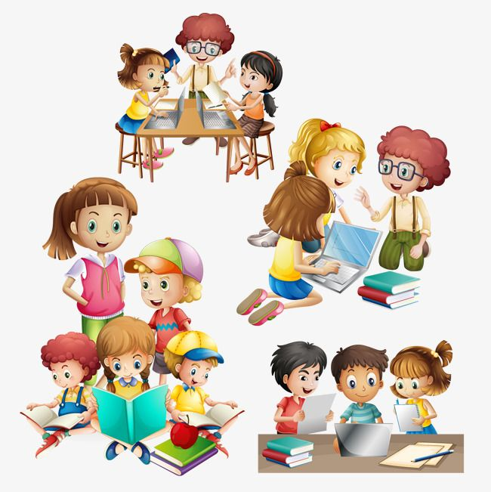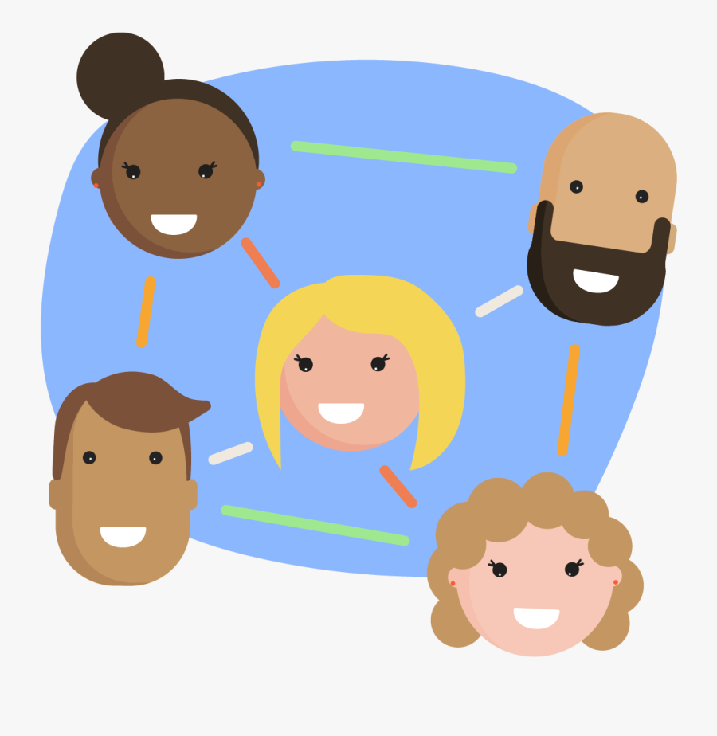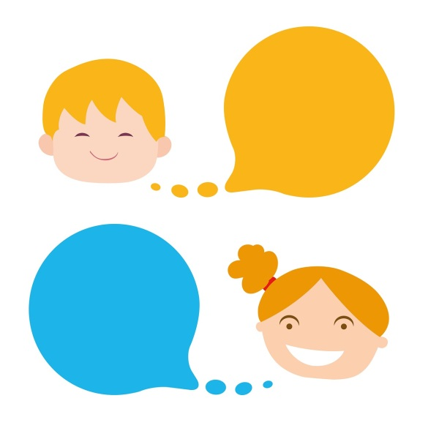
Stereotype | A fixed and often untrue opinion of someone or something.
Acceptance | The act of accepting something.
Courtesy | Good manners or politeness.
polite | Having or showing good manners or respect.
cultural | A pattern of behaviour shared by a group of people.

Scripture and prayers that we will use: | Images I may see:
My commandment is this:  Love one another, just as I have loved you.  John 15: 12  Loving Father, we thank you for the wonder and gift of each person made in your image and likeness. Help us to be courageous in loving all despite our uniqueness and difference. Amen. | 